Chapter 11, Solution 42.

(a) S=120,
(b) 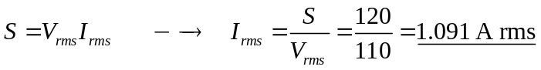

(c) 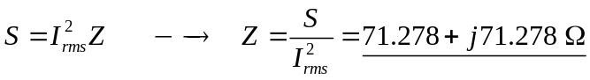

(d) If Z = R + jL, then R = 71.278 Ω
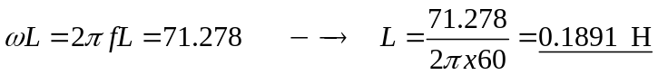= 189.1 mH.

